

**Welcome to our Art Exhibition on**

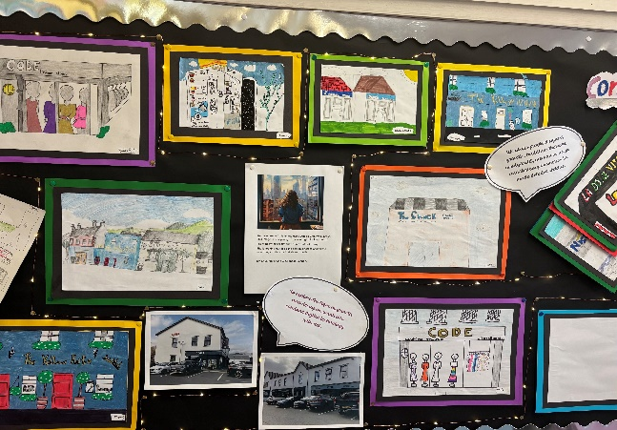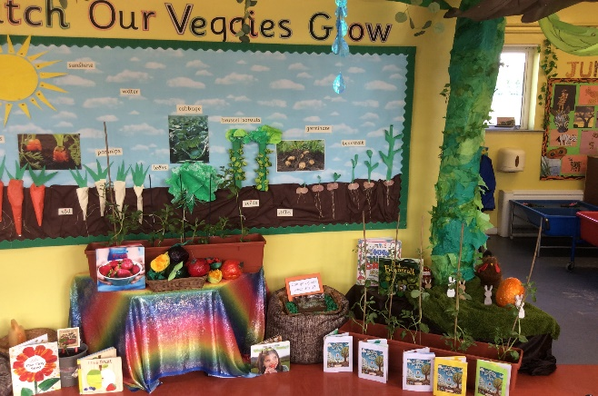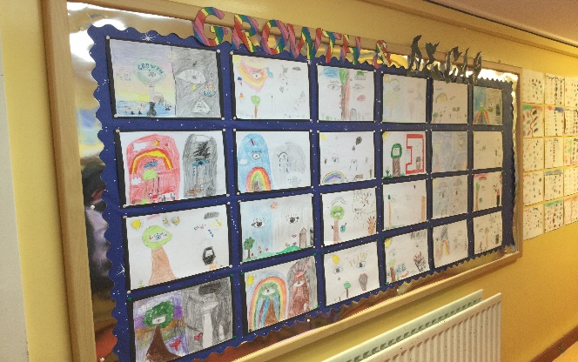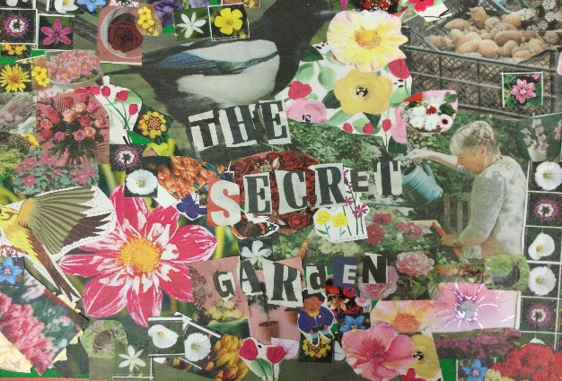**Growth and/or Decay**

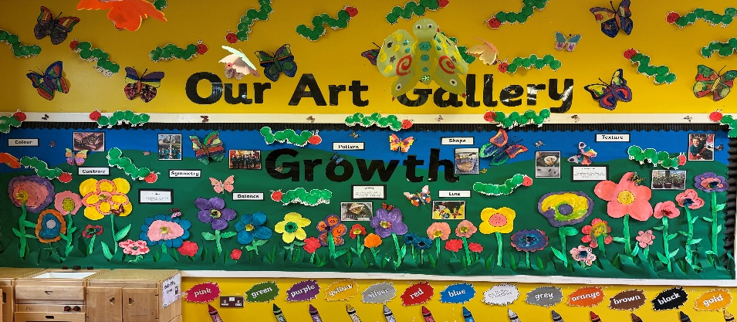

**Nursery**

The children engaged in an art project focused on fruit and vegetables exploring a variety of materials and techniques. They began by making representational drawings using paint, markers, pastels and paper, carefully observing the colours and shapes of different produce. They also created 3D fruit/vegetables using paper mâché. During Show and Tell the children spoke confidently about the fruit and vegetable. They also learned a song about a seed growing and we constructed a large beanstalk using chicken wire and tissue paper. We printed with real fruits and vegetables and crafted unique pictures using dried fruit.

**Primary 1**

Step into our spring meadow with a variety of butterflies fluttering around the room, from our observational drawings to our digital art, and from our doubling butterflies to our printed ones. See how we nurtured spinach from tiny seeds to flourishing plants and lovingly cared for caterpillars, watching them transform into beautiful butterflies while documenting each step of the life cycles in our concertina diaries. We can't wait to share this ‘Growth’ project with you – it's sure to be a fluttering good time!

**Primary 1/2**

The magnificent oak tree takes centre stage in the P1/2 class display. Taking inspiration from our non-fiction work on ‘The Oak Tree’ and fiction work on ‘The Lonely Giant’, we discussed the importance of trees and forests in providing a habitat for birds and animals. We also examined why the giant was lonely when he destroyed the forest, and the birds and animals disappeared and how happy he was when the forest was restored, and the animals returned. Through our artwork we wanted to show the vibrancy of the forest and so used a variety of mediums and techniques to create an amazing oak tree which was enhanced by the completion of birds and animals made using paper mâché and decorated with a variety of materials.

**Primary 2**

As part of our Art display, Primary 2 created a collaborative display based on *The Selfish Giant* by Oscar Wilde. We explored the story’s key themes of kindness, sharing, and transformation. Our artwork represents the change in the Giant’s Garden from a cold, grey space to a vibrant, joyful place full of life. Pupils used a variety of materials and techniques to contrast the two sides of a tree: one side has dark colours and cool textures (such as cotton wool for snow) to show the selfish Giant’s winter, and bright colours, soft petals, painted leaves, and shiny materials to bring spring to life.

This project allowed the children to express their understanding of the story through visual art, while developing creativity, teamwork, and an appreciation for how our actions affect others.

**Primary 3**

Our project aims to portray how the Happy Prince’s growth in his love for others, leads to the decay in the materialistic beauty of his statue. Similarly, the Swallow’s growth in love for the Happy Prince leads to his death (decay) by overstaying the seasons. But in the end growth triumphs over decay where the Happy Prince and the little Swallow are rewarded for their kindness and restored to their former glory in Heaven.

**Primary 3/4**

The children in P.3/4 explored the themes of growth and decay inspired by "The Secret Garden" to create a vibrant and imaginative display of creativity. A variety of artistic mediums were used to capture the transformation of the garden from a neglected space to a vibrant, blooming sanctuary.

**Primary 4**

As a foundation for this project the children sketched their interpretation of what growth and decay meant to them. This stimulus enabled the children to express themselves in wonderful art pieces.

Growth: Zentangle (growth of different patterns). Individual class portraits. Clay flower creations. Spring paintings of landscapes. Easter clay creations to represent new life.

Decay: Planning, making and evaluating their 3D robots using recycled materials. Planning and making their Egyptian death masks and researching an Egyptian name to accompany the mask.

**Primary 5**

Primary 5’s project was based on our WAU topic ‘Water’. The children discussed the importance of water for life and the concepts of growth and decay in nature. Using recycled materials encouraged the children to think about sustainability while teaching the importance of recycling. The project encouraged the children to express their creativity by transforming everyday items into unique and imaginative artworks, while thinking about sustainability and nurturing a sense of responsibility towards the environment.

**Primary 5/6**

For the school’s art theme of Growth and Decay P5/6 decided that they would look at this from an Artificial Intelligence perspective. After initial brainstorming of ideas, it became obvious quite quickly that robots were going to play an integral part of our plans. The class set about coming up with ideas that linked into our World Around Us thematic unit on The Environment. We decided to have a focus of how Artificial Intelligence (when used negatively) can have a very destructive influence on the world.

**Primary 6/7**

We have linked the topic of ‘Growth and Decay’ to the human mindset.  ‘Growth’ being connected to a growth mindset and’ Decay’ linked to a negative mindset.  The students drew their own interpretations of what a growth and negative mindset looks like.  Through a ‘brainstorming’ session, we decided that an effective way of physically representing a Growth/ Negative mindset was through a tree.  With half of the tree full of life, blossoming, green etc (growth mindset) and the other half dead, lifeless, dull etc (negative mindset).

**Primary 7**

The topic of Growth and Decay immediately captured the attention of Primary 7. Having studied ‘The Great Hunger’, it was clear that the growth of some, meant the decay of others. This juxtaposition was the focal point for the children’s artwork, with a particular focus on the Workhouses. These harsh institutions were established to house the poor and destitute and formed a fitting bedrock for the decayaspect of their artwork.

The children chose their local area of Camlough to examine areas of growth and development which have enhanced the village. The connection between growth and improvement was evident when they examined some recently established buildings and modern renovations. The children initially completed observational drawings of growth as well as capturing the cyclical nature onto acetate sheets and then projected them onto a screen.

**Thank you for visiting our Art exhibition. We hope you have enjoyed seeing the wonderful artwork that has been produced this term by every class in our school. We look forward to watching our budding artists continue to explore and develop their skills in this area.**

**Nora King (Arts Coordinator)**

